Supplementary Material 1
Pairwise sequence-identity heatmap of the macrolide esterases.
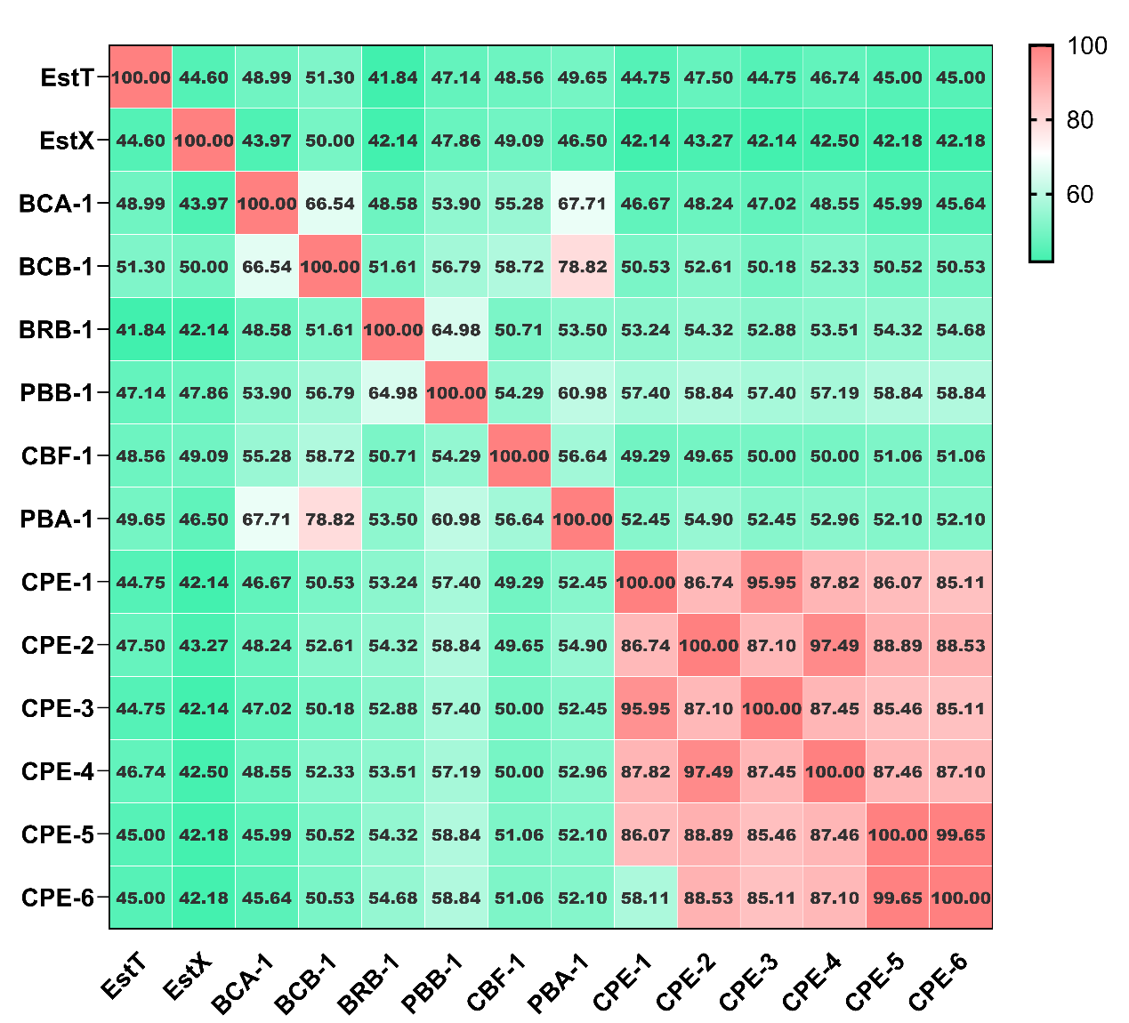
Supplementary Material 2
Spot-plating assay showing growth of E. coli strains carrying CPE1–6 or pET28a on Mueller–Hinton agar supplemented with 4 mg/mL tylosin at serial CFU concentrations.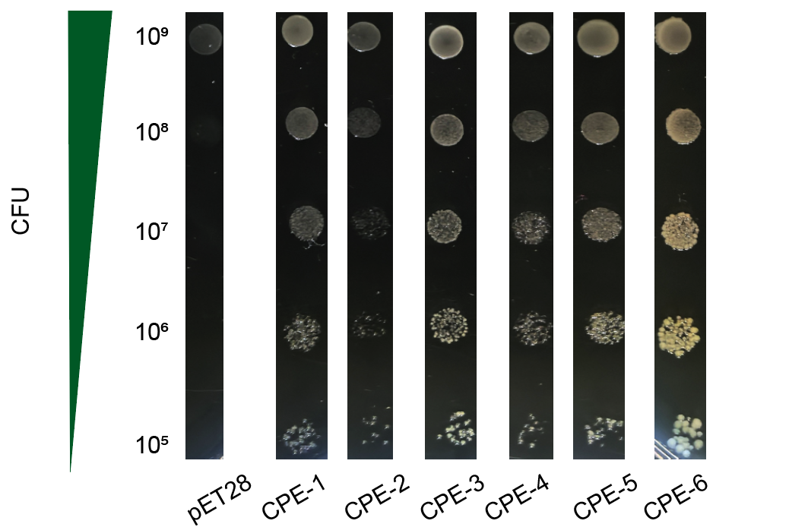
Supplementary Material 3
Agar well diffusion assay and heatmap of macrolide degradation by purified recombinant CPE proteins. 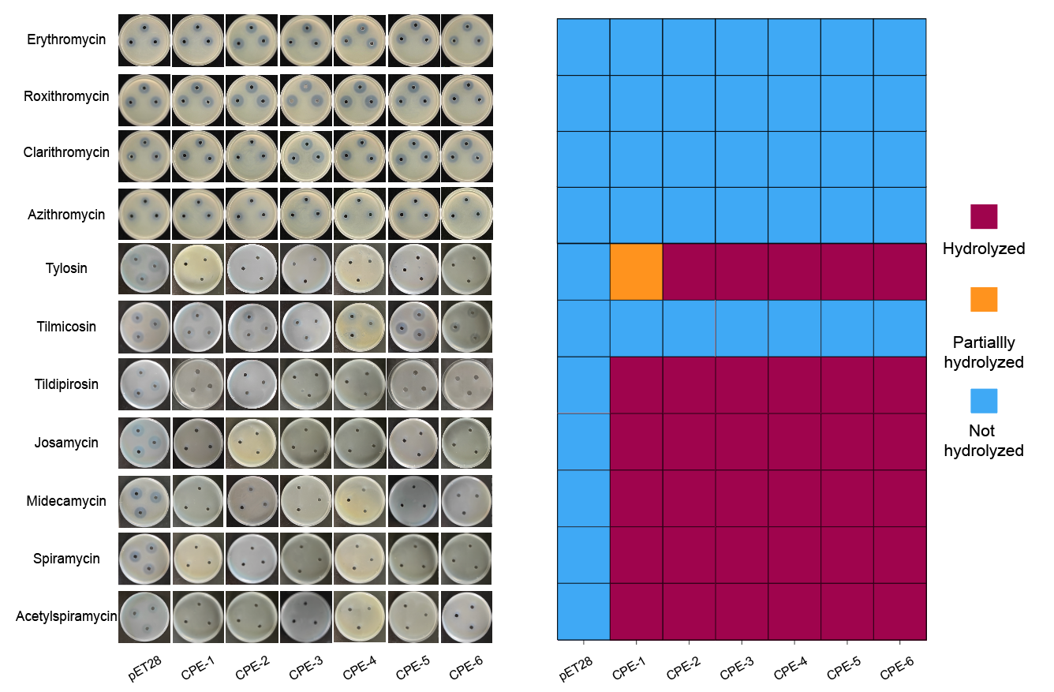
- Inhibition zone assay showing antimicrobial effects of degradation products. (B) Heatmap illustrating antimicrobial activity.
Supplementary Material 4
SDS-PAGE analysis of purified recombinant CPE2–CPE6 proteins. Molecular mass markers (kDa) are indicated on the left.
